**How to select proper anchoring adhesive**

Anchoring adhesive has now become an important reinforcement material for the building reinforcement industry, and a large number of adhesive manufacturers and brands have emerged on the market which requires you to know how to select the right one to avoid wrong choice.

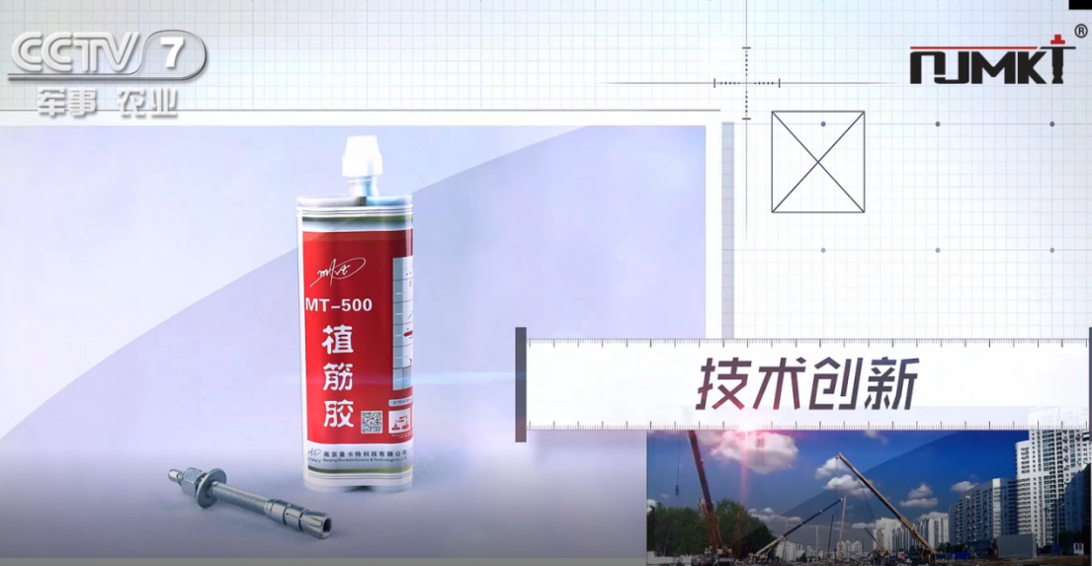

**NJMKT has been reported by China Central Television 3 times**

**How to choose a proper material?**

Technical Specifications for Safety Identification of Reinforcement Materials for Engineering Structures GB50728-2011 stipulates that rebar planting should be adopted for the modification of epoxy or modified vinyl lipid adhesive, bearing structure reinforcement project is strictly prohibited in the unsaturated polyester resin and alkyd resin as adhesive, curing content of 99% or higher, other is strictly prohibited to ethylenediamine adhesives are as ingredient of the curing agent, and must ensure safe non-toxic, does not contain the irritant gas such as styrene.

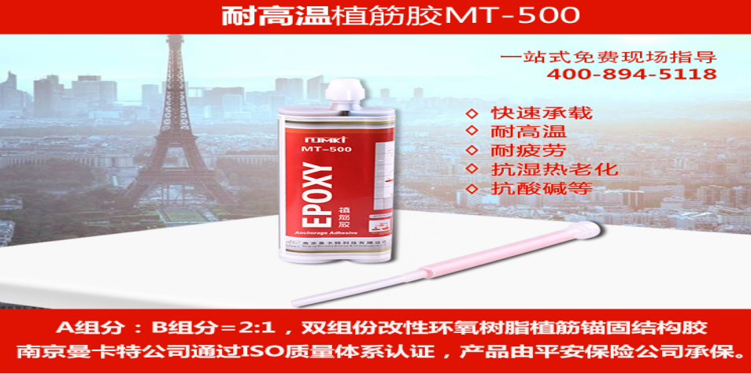

**Mankate modified epoxy resin**

When selecting the anchoring adhesive, you can analyze whether to meet the conditions of high quality adhesive from the following aspects:

1. Is the composition modified epoxy;
2. Is the colloid tenacity and high anchoring force
3. The molecular structure has more polar functional groups such as hydroxyl
4. A product can meet a variety of substrate purposes
5. It can be applied to almost any drill hole diameter and embedment depth.

Apparently, Mankate anchoring adhesive can completely satisfy the requirements that mentioned above, mankate adhesives has rapid load, high temperature resistance, fatigue resistance, anti wet and heat aging properties, all indicators have reached the national standard requirements through strict national building materials testing, with general administration of quality supervision, inspection report.

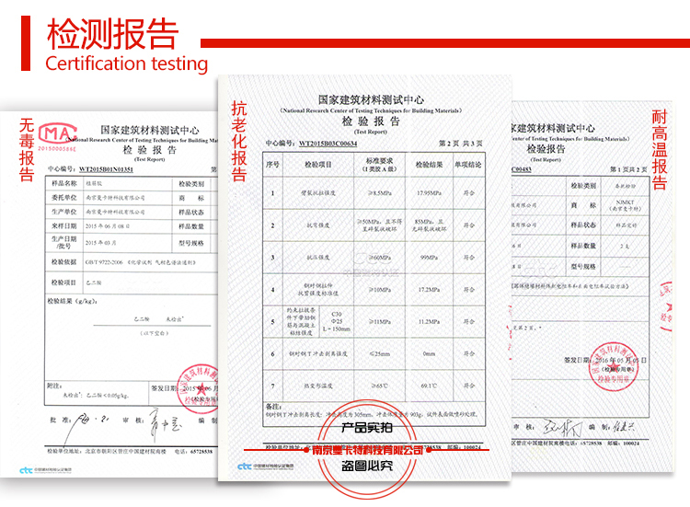~

Mankate anchoring adhesive has enjoyed good reputation through 18 years experiences, our products have been successfully applied in many large projects interiorly and overseas, including but not limited to a few China nuclear power plants. We provide you with pre-sale, sale, after-sales service.

**Mankate Hotline：+86 400-894-5118**